MECHANICAL ENGINEERING DEPARTMENT

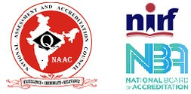
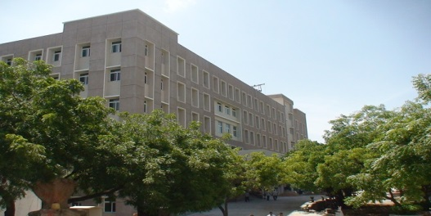
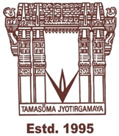

VNR VIGNANA JYOTHI
INSTITUTE OF
ENGINEERING AND
TECHNOLOGY
www.vnrvjiet.ac.in

About the Department

AICTE Approved, UGC Autonomous, JNTUH Affiliated, UGC “College
with Potential for Excellence”
Accredited by NAAC with
“A++” grade
B.Tech Program Accredited by NBA
NIRF: 113th Rank (Engg.)
QS I-GAUGE “DIAMOND” Rated
ISO 9001:2015 Certified
JNTUH Recognised Research Centre
Mechanical Engineering is an ideally diverse subject and I think, it can be simply said with a slogan ‘Nothing moves without Mechanical Engineers’. Whether it is an aircraft, robot, space or utility vehicle, train, satellite or an artificial human body part replacement, mechanical engineers play a significant role.
The Department of Mechanical Engineering at VNR VJIET aims at generating skilled technical manpower, providing problem-solving methods to societal and industrial challenges, and engaging in cutting edge engineering research. The mechanical engineering department at the VNR VJIET is one of the top-ranked in Telangana State, attracting the highest quality of students.
The department has started its journey in the year 1995. The department offers one undergraduate program - B.Tech. (Mechanical Engineering) and Two Masters Programs - M. Tech. in Advanced Manufacturing Systems and M. Tech. in CAD/CAM and offers Doctoral programs through JNTUH and AICTE. The department is backed by professionally experienced and highly qualified faculty and supporting staff. The department enrich with 20 Doctorates in diversified specializations from premier organizations across the world and 16 faculty are pursing Ph.D.
The focus of our curriculum is to promote technical competence, problem solving skills and innovation of new technologies. Department offers wide spectrum of optional courses to students to pursue their interest. The syllabi are periodically updated for introducing new technological developments as required by the industry.
The department has state of art labs, research and computational facilities and wide range of software’s to support academic programs. Faculty members of the department executed externally funded research projects in Solar Energy Applications, Joining Technologies, Characterization of Bone and Biomaterials, Computational Thermodynamics of Materials, Machining of Super Alloys, Advanced Thermal materials, Biofuels, Composite Materials etc. We also offer consultancy services in Rapid Prototyping, Composite Materials, and Process Optimization areas.
Our Graduate and Undergraduate students are encouraged to undertake various research projects in Rapid Prototyping, Digital Manufacturing, Joining Technologies, Composite Materials, Material Characterization, Solar Energy Applications, Automation and Robotics, Machine Learning Applications etc. Our students also get an exposure to emerging technological developments as members of various professional societies like ASME student chapter and through internships, industrial visits, expert lectures, collaborative projects and participation in conferences, workshops, competitive events.
Dr. B Satyanarayana
Professor& Head of the Department
Vision
To develop into a Centre of Excellence in Education and Research in the field of Mechanical Engineering, consistent with the contemporary and future needs of the country.
Mission
To impart high quality education in Mechanical Engineering by using modern pedagogical tools so as to make the students technically competent in their chosen fields and socially responsible.
To inculcate quality research by developing linkages with Industry and R & D organizations in India & abroad.

Programmes Offered:
B.Tech (Mechanical)
M.Tech (AMS)
M.Tech (CAD/CAM)

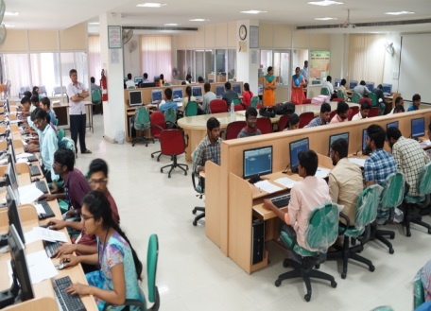
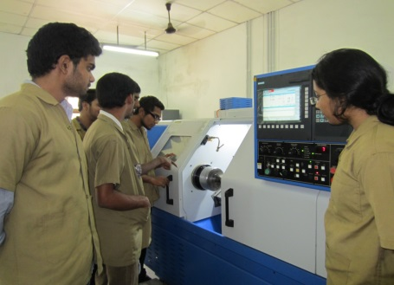
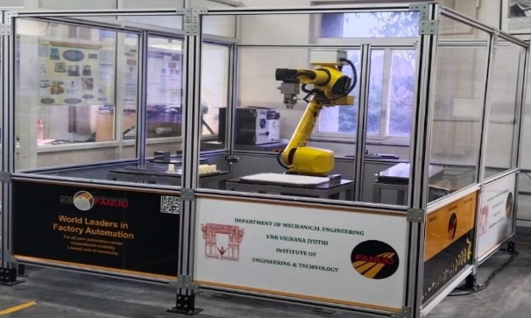
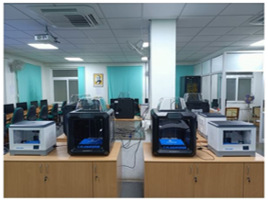
CAD LAB
CNC LAB
AUTOMATION & ROBOTICS LAB
ADDITIVE MANUFACTURING LAB

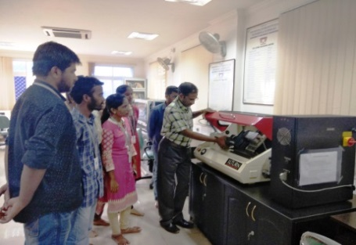

CAM LAB

Courses offered
The Mechanical Engineering Department offers both UG and PG programs: B. Tech in Mechanical Engineering, M.Tech in Advanced Manufacturing Systems and CAD/CAM.

Intake
- B.Tech Mechanical Engineering: 120
- M.Tech Advanced Manufacturing Systems: 18
- M.Tech CAD/CAM: 12
Infrastructure
The department has spacious and ICT facilities provided classrooms and laboratories with advanced state of the art facilities such as additive manufacturing, Robotics and Automation, Industry oriented manufacturing machines and testing equipment.
Laboratories
Department has 15 laboratories and has an exclusive laboratory for emerging technology on 3D Printing, Centre of Excellence in the area of Joining Technology, centre for Solar Energy Materials and Composite Materials facility.
Industry Sponsored Laboratory
The department established a Laboratory, in the area of Thermal Engineering, in which the equipment is funded by BLUE STAR Ltd., to provide hands on training to our students, staff and the technicians nominated by the company.

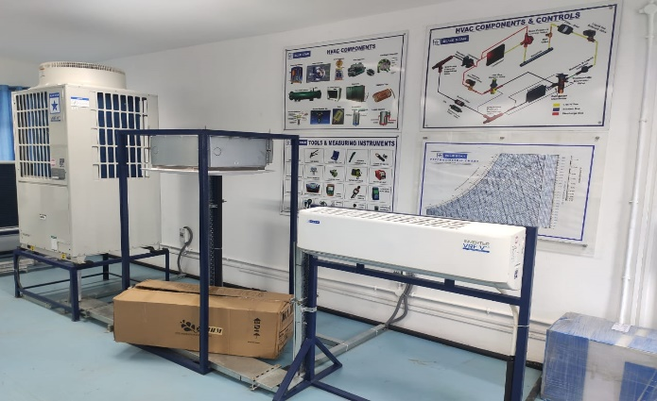

INDUSTRY SPONSORED BLUE STAR LAB
Faculty
The department has 38 well experienced faculty with 11 supporting staff.
More than 50% of faculty are doctorates and 16 faculty are pursuing their doctoral degrees.
Research and Development
Faculty have received grants worth of Rs.1.45 crores from various funding agencies and the department has 5 granted 14 published patents. The faculty has published more than 432 research papers in good quality journals and conferences from the last decade, one among has the highest impact factor of 35.34.
Faculty Achievements
Dr. Ajay Kumar has executed a research project on “Development of Micro-nano Structures for Solar Distillation” of worth Rs.2.85 lakhs funded by TEQIP-III. He is currently working on DST project titled “Development of hierarchical structures for solar desalination” of worth Rs.40.73 lakhs. He received innovative scientific research and dedicated teaching professional award from Indian Society of Mechanical Engineering.
Dr. B. V. R. Ravi Kumar has executed 2 research projects of total worth Rs. 25, 61,000/- funded by AICTE and DRDO (CARS) and received a research grant of Rs. 7, 84,314/- sanctioned by AICTE in 2020 to conduct research in the area of Friction Stir Welding. He guided two Ph.D. scholars and two more scholars are pursing Ph.D. under his guidance.
Dr. Y. Shivraj Narayan, Professor received UGC travel grant thrice for presenting research papers in ASME 2013 and 2015 IMECE, TMS 2018 conferences at USA. He organized AICTE sponsored international conference on Sustainable Development in Mechanical Engineering (SDME 2020) and Atal online FDP on 3D Printing and Design (2021).
Dr. N. Kiran Kumar organized AICTE sponsored Short Term Training Programme on “Advanced Techniques in Modeling and Analysis for Mechanical Engineering (ATMA 2020)” and completed research project on Characterization of ply drop phenomenon in FRP Composites funded by TEQIP-III of worth Rs.2.92 lakhs in the year 2021. He received innovative scientific research and dedicated teaching professional award from Indian Society of Mechanical Engineering.
Dr. K. Aruna Prabha received UGC travel grant of Rs 2, 33, 285/- for presenting research papers in ASME 2019 IMECE Conference from 8th to 16th November 2019 at Salt Lake City UTAH, USA.
Dr. Satya Prasad Paruchuru executed AICTE sponsored research project under RPS, amounting to Rs.17.52 lakhs on Multi-Scale Mechanical Methods for Characterization of Bone and Biomaterials during the period 2012-16. He received a travel grant of Rs.1.49 lakh for presenting papers at an ASME conference, IMECE-P, in November 2018.
Dr. G. Srinivasa Gupta has completed a research project titled “Development of Procedures for Computation of Titanium - Vanadium Binary Alloy System using Cluster Variation Method” by the research grant of worth Rs.9.32 lakhs sanctioned by Aeronautical Research and Development Board, (DRDO) during the period 2014-17.
Dr. B. Satyanarayana has completed a minor research project titled “Optimization of controllable turning parameters for High-speed Dry Machining of Super Alloys by measurement of Tool Wear” funded by UGC of worth Rs. 3.5 lakhs during the period 2014-16.
Dr. Jayashri N. Nair received grants of 3.30 lakhs from UGC for minor research project titled “Cultivation of micro algae and characterization for suitability as an alternate fuel” in the year October 2016 and has successfully completed it.

Research Facilities in the Department

Department is equipped with wide range of CAD/CAM software like AutoCAD, CATIA, Creo, ANSYS, Edgecam, CNC trainer, Adams, Mastercam, FlexSim, MATLAB, Minitab, Artec Studio, HyperMesh and 128 workstations with latest configuration to cater to the UG and PG programs for design modeling and analysis of engineering products and research projects.

Department possesses the following research facilities:
- 3-D Printers (FDM & SLA), 3-D scanner for and prototype development visualization of products.

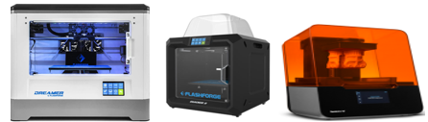
- A Centre of Excellence in Joining Technology is established by the department with necessary infrastructure such as Digital Metallurgical Microscope, Digital Ultrasonic Flaw Detector, and Digital Micro Vickers Hardness Tester along with Thermo-Calc and Mathematica software to conduct advanced research in joining technologies.

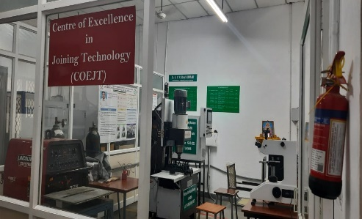
Centre of Excellence in Joining Technology

- Additive Manufacturing Lab is equipped with 36 workstations having access to modeling, analysis and simulation software to carry out academic and research projects.
- CNC Lathes and CNC Milling machine apart from machine shop to manufacture complex and precise components.
- Automation & Robotics Lab is equipped with Pneumatic and Hydraulic Trainer kits, Industrial PLC and Microprocessor Trainer kits, Sensor kits, 6 Axis Industrial Robot, 5-Axis Robot Arm Trainer, Electric VVVF Drive System and Robotic Simulation Software, ROBOGUIDE and Automation Studio.

- Composite Materials Facility is developed to carry out academic and research projects on characterization of composites, sandwich composites, damage induced composites. A research project on Characterization of Ply Drop Phenomenon for FRP Composites funded by JNTUH/TEQIP-III CRS is completed.
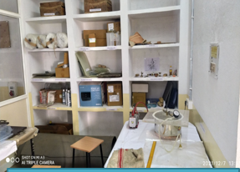
Composite Materials Facility

  - A high energy absorption structures facility is developed to carry out academic and research projects on solar desalination applications.
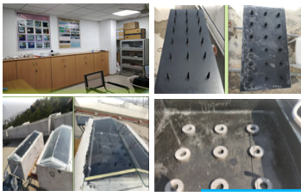
Centre for Solar Energy Materials

  - UTM Instron (3386) to carry out innovative projects on Biological and Innovative Materials.
  - Digital library to support faculty and students to do projects and research by providing access to E-Journals, E-Books, text books and project reports.
Student Activities
Students are encouraged to join academic and professional organizations to build leadership, communication, and networking skills. The student chapter of the American Society of Mechanical Engineers (ASME) is a highly active organization, promoting teamwork and collaboration throughout the duration of a student’s academic career.
The students participate in various national and international competitions under the ASME student chapter of the department and have won distinguished prizes and awards nationally. One of the Alumni has invented world’s first A.C Helmet through his start up supported by the Institution.
Alumni
Alumni are our ambassadors to the outside world. Alumni-Survey is collected on a regular basis after they have spent time in the professional world. Their feedback serves to consolidate our steps to improve the program in a multifaceted direction. Every year alumni association is organized in the college under the banner YUGMA. Alumni across the industry gather on this day and share their experiences and collaborations with the outside world.

Research and Development- Students

UG and PG students have an opportunity to work and involve in the ongoing research projects in their final and pre-final semesters. Research areas in the department are broadly classified into:
- Solar Energy Applications
- Joining Technologies
- Biofuels
- CAD/CAM
- Robotics and Automation
- Composite Materials
- Computational Fluid Dynamics
- Additive Manufacturing
- Industrial Engineering and Management
- Machine Learning Applications
- Manufacturing
- Material Characterization
- Predictive Analytics in Manufacturing
- Robotics and Automation
- Theoretical and Applied Engineering

Student Achievements
- Mr. Y. Kausthub Kaundinya, Mr. Nikhil Pasari, Mr. Sreekanth Kommula, Mr. Anand Kumar (2015-16) have received Best Student Project Award by TCS.
- Ravva Saranya, elected as a student member for the board of governors of The American Society of Mechanical Engineers year 2020.
- Alumni of the department incubated startups for the manufacture of Air-Conditioned Helmets and development of prosthetic arm.

Connect with Industry
Mechanical Engineering Students at VNRVJIET benefit by experts coming from both industry and Academia. Knowledge sharing sessions are conducted throughout the academic calendar to give students insights into the real-life applications of their subjects in industry.

Industry Visits
Industrial visits are organized for students to give them the platform to know about the innovative practices in industries and share leadership approaches that have led to their success.
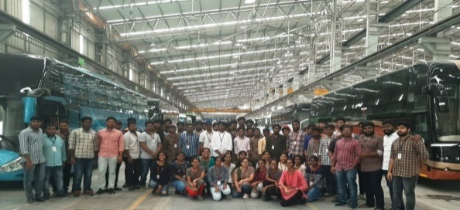

Expert Lectures
The department organizes expert lectures by inviting experts from academia, research organizations and Industry like IIIT’s, NIT’s, JNTUH, OU, DRDO etc. to make students aware of the latest technological advancements and trends in industry. The expert lecturers encourage the students to streamline their learning with industry demands.

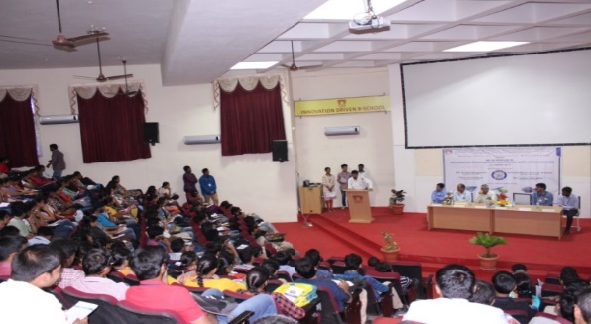

Program Educational Objectives (PEOs) - B.Tech.

- To prepare students for successful careers as mechanical engineers in organizations that meet the needs of Indian and global/multinational industrial/research establishments.
- To provide a strong foundation in mathematical, scientific and engineering fundamentals in both domain and cross domain spheres, that enables students to visualize, analyze and solve mechanical engineering problems and be innovative and research oriented.
- To train students with a wide spectrum of scientific and Mechanical engineering courses so that students could comprehend, analyze, design and create products and services which promote entrepreneurship culture in the campus that address real life problems, which are efficient and cost effective.
- To inculcate professional and ethical attitude in students, impart effective communication skills and ability to work in teams with multidisciplinary approach, be part of and interact with professional bodies so as to resolve engineering issues of social relevance.
- To provide students with an academic environment that fosters excellence, leadership, yearning to pursue higher studies and passion for lifelong learning so as to have a successful professional career.

Our Prominent Recruiters
Contact us

Dr. B.Satyanarayana,
Prof. & Head,
Department of Mechanical Engineering
Email: mechhead@vnrvjiet.in
040-23042758 ext. 4200
Dr. K. Balashowry, Professor,
Department Mechanical Engineering,
Member- IIIC
Ph: 9700308734
Email: balashowry_k@vnrvjiet.in

