A Report on Entrepreneurship Development Cell & MSME Vignana Jyothi Technology Business Incubator (MSME VJTBI) Activities for the Month of September, 2023.

I) MSME & VJTBI Activities:

- VNRVJIET MSME Business Incubator has received 42 Ideas under the scheme of MSME Idea Hackathon 3.0 (Women). VNRVJIET MSME Business Incubator has short listed 21 ideas among received 42 ideas through screening committee on 28.08.2023 and uploaded 20 Ideas in MSME Web Portal on 03.09.2023.

II) ED Cell Activities:
- ED Cell has organized the ISB Orientation Session on Young Leaders Programme (YLP) of ISB by Mr. Arun Prakash, Higher Education Marketing Professional, Indian School of Business (ISB) on 15.09.2023 at Dr.A.P J Abdul Kalam Auditorium from 02.45 PM to 04.45 PM.122 Students of III and IV year B.Tech. students from all the branches attended.
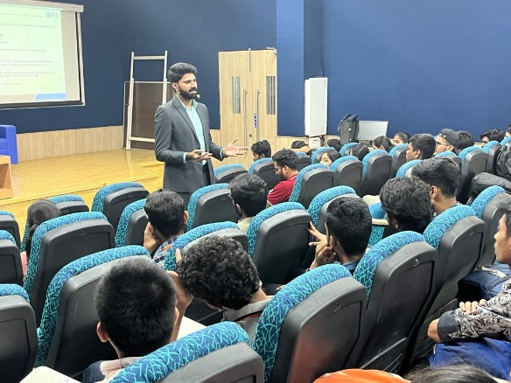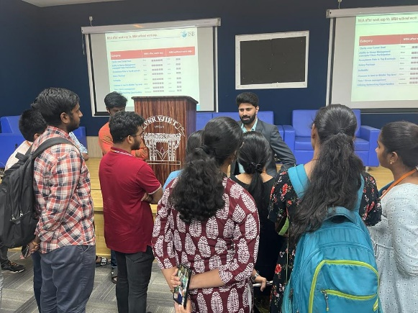
ISB Orientation session on Young Leaders Programme (YLP) by Mr. Arun Prakash, Higher Education Marketing Professional, Indian School of Business (ISB)

- On the eve of the Teacher's Day, Entrepreneurship Development Cell (ED Cell) in association with IIC (Institution’s Innovation Council) organized an online webinar on ‘Be the Game Changer’ by Mr. CA Ram Prayaga, Founder of Finance Box, and Mr. Sanjay, Director Associate of the Finance Box, Hyderabad from 1:30 PM to 2:30 PM on 05.09.2023.48 B.Tech. students from all the branches attended the webinar.
Online webinar on ‘Be the Game Changer’ by Mr. C A Ram Prayaga

- As a part of the Induction program, Entrepreneurship Development Cell (ED Cell) has given orientation about Entrepreneurship Development Cell and its activities to the 1st year B.Tech. student during 12, 13 and 14 September 2023 at K.S.Auditorium. 1792 students from all branches of I year B.Tech attended the Induction program.
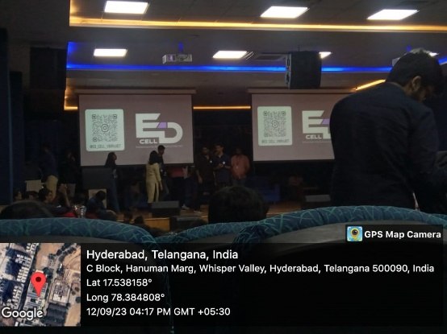
Entrepreneurship Development Cell orientation during Students Induction Program

- Dr. S.V.S.S. Srinivasa Raju and M. Venkata Ramana, Coordinators of ED Cell attended the second meeting of Education & Skills Panel of CII Telangana on 16.09.2023 from 3.30 PM to 04.45 PM through online MS Teams Platform discussed regarding preparation of a tentative schedule for Organizing Conference, Academic Leadership Programme, Faculty and students visits to the Corporates/Innovation Lab, FDPs, Professor of Practice and Faculty Internships in consultation with all the stake holders of the forum through CII.

(ED Cell & MSME VJTBI Coordinators)
Dr.S.V.S.S.Srinivasa Raju, Professor of Mechanical Engineering, Coordinator, ED Cell
& Manager, MSME Business Incubator
Dr.M.Venkata Ramana, Professor of Automobile Engineering & Coordinator, ED Cell.

