A Report on Entrepreneurship Development Cell & MSME Vignana Jyothi Technology Business Incubator (MSME VJTBI) Activities for the Month of June, 2023.

I) ED Cell Activities:

- Dr.S.V.S.S.Srinivasa Raju and Dr.M.Venkata Ramana Coordinators of ED Cell have prepared and submitted a Report pertaining to Entrepreneurship Development Cell in the form of Document to PAAC for NAAC Purpose on 03-06-2023.
- Dr.S.V.S.S.Srinivasa Raju and Dr.M.Venkata Ramana Coordinators of ED Cell along with other Faculty members & Students have participated in Industrial Innovation & Technology Expo (IITEX Expo)-2023 at Hitex Exhibition Center, Hyderabad, organised by The Federation of Telangana Chambers of Commerce and Industry (FTCCI) and Government of Telangana, to promote new market access initiatives, create awareness, and empower the MSMEs and upcoming Startups who are venturing into setting up MSMEs with new age technology, innovations & sharing Industry best practices. Also encouraging B2B business networking amongst the MSMEs by exhibiting their products in different stalls during 28-06-2023 to 30-06-2023.
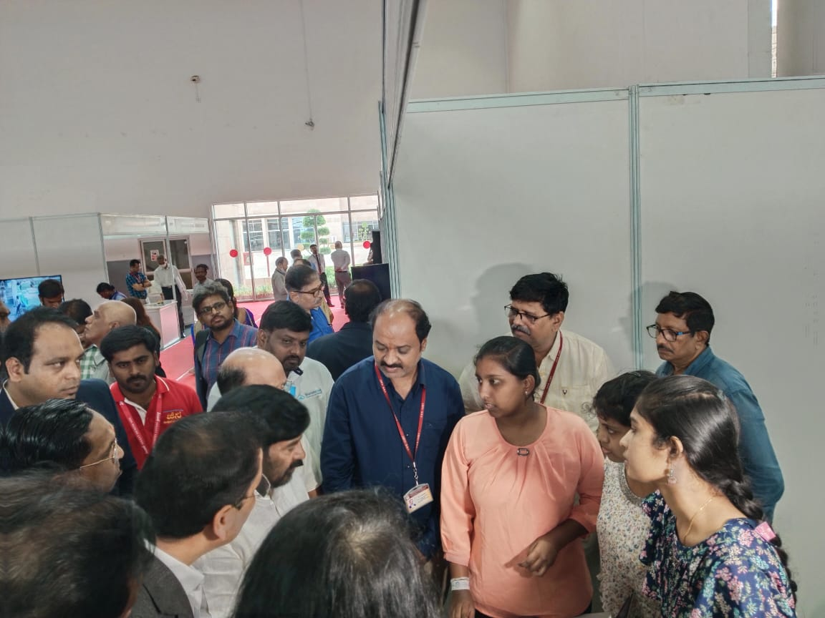
Faculty ,Students and Mr Jagadeswar Reddy Minister of Industry Govt of Telangana at the Stall in Hitex IIT Expo-2023 on 28-06-2023
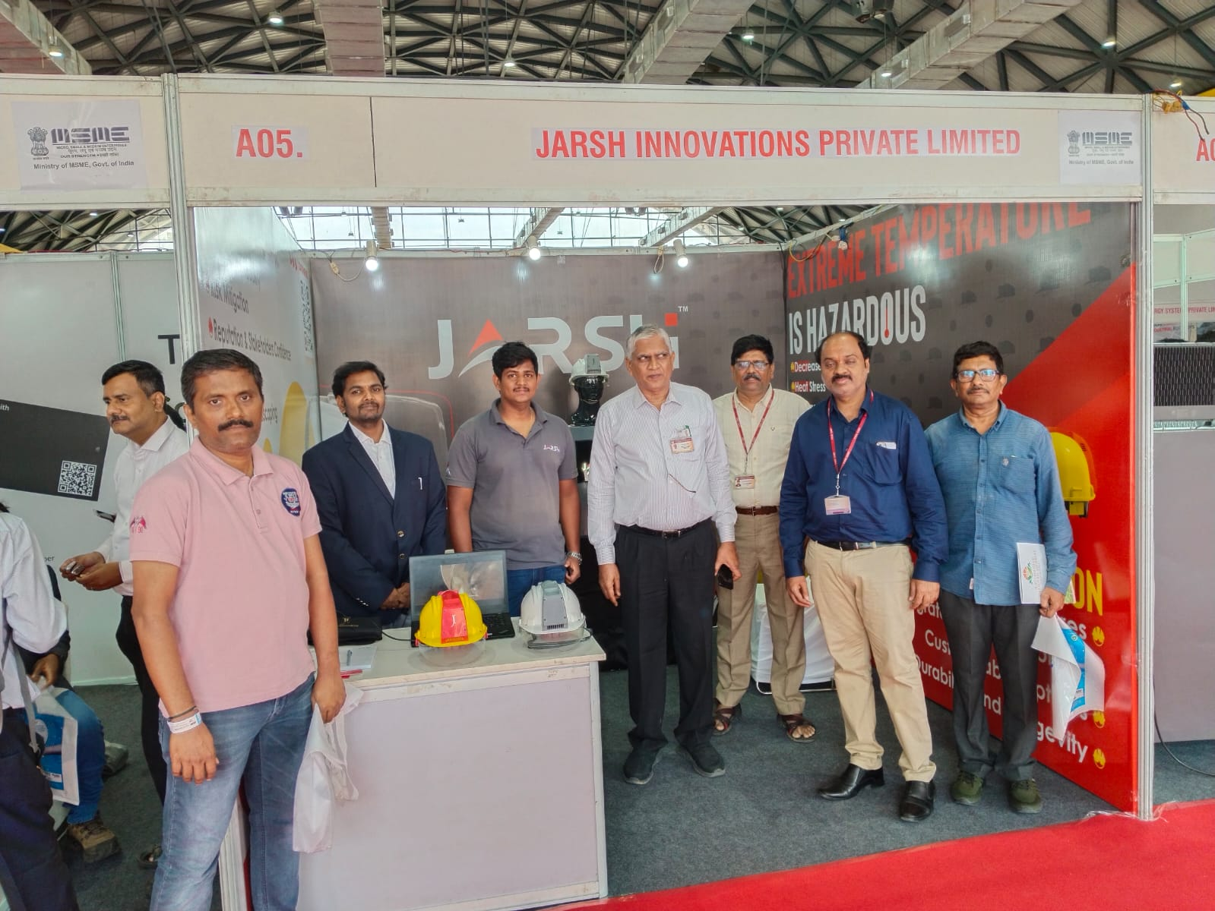
Faculty ,Students and Dr.C.D.Naidu Principal VNRVJIET the Stall in Hitex IIT Expo-2023 Shed No:1 on 28-06-2023
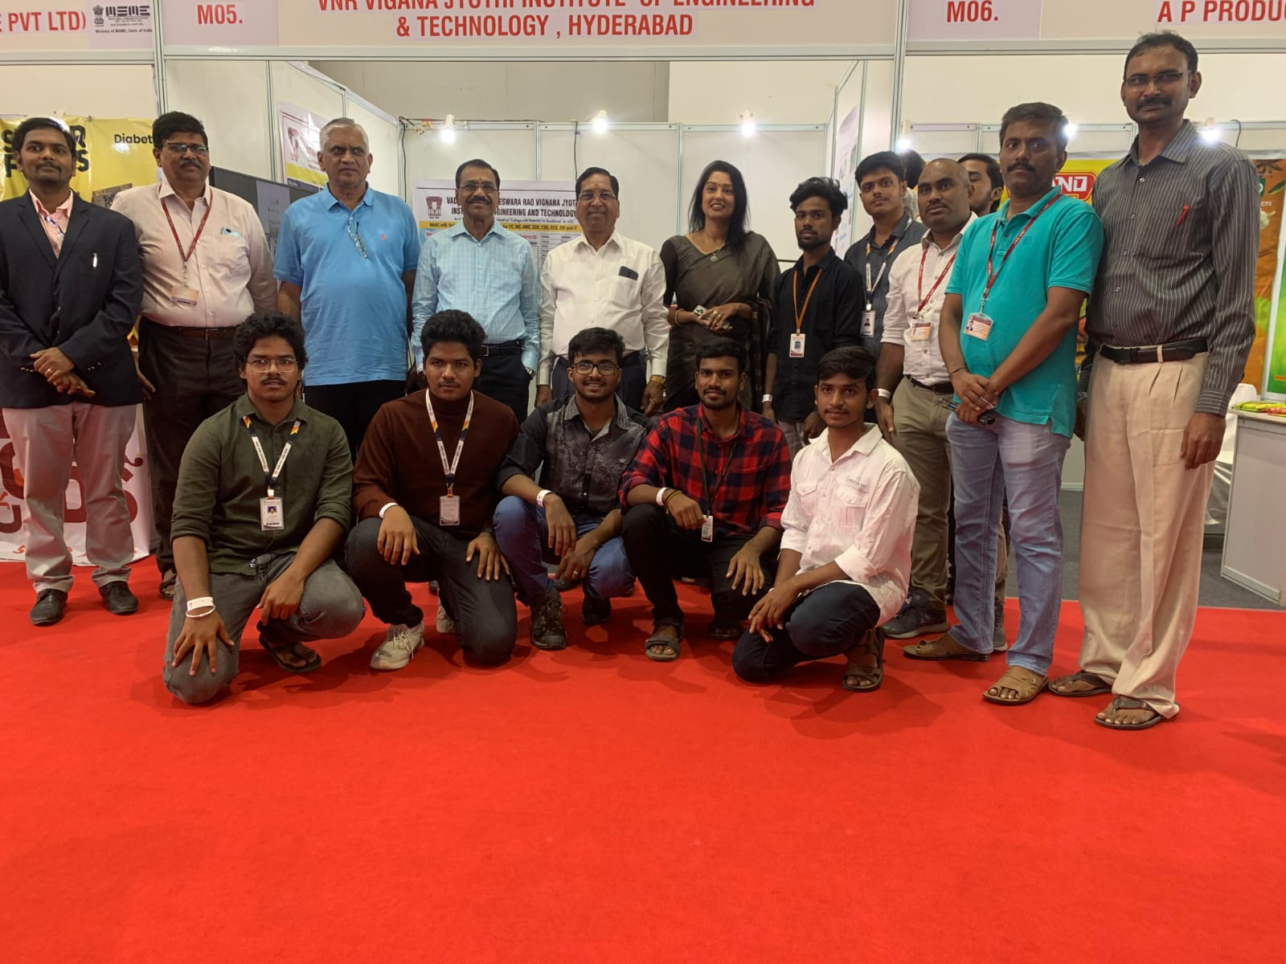
Faculty ,Students ,Principal and Sri J.S.Rao garu at the Stall in Hitex IIT Expo-2023 Shed No:1 on 29-06-2023

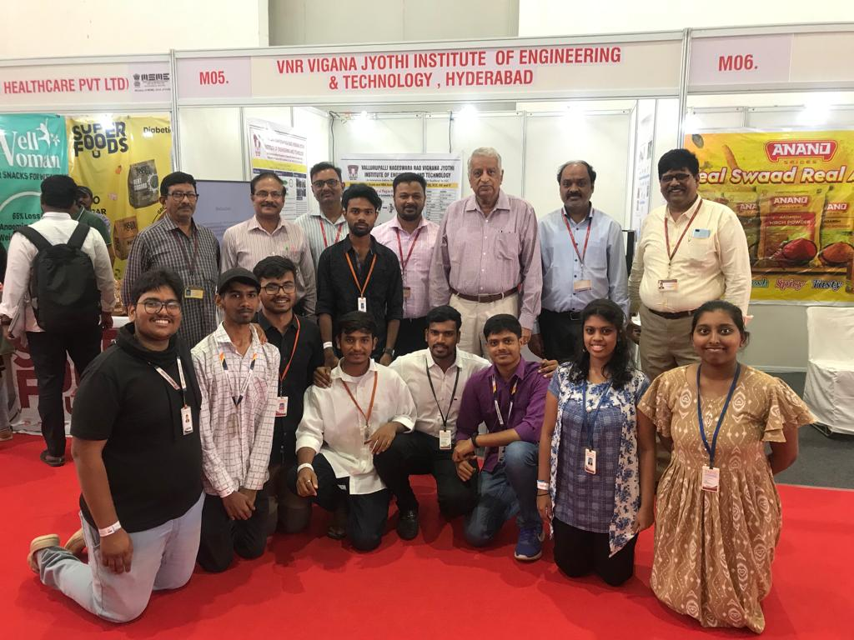
Faculty ,Students ,Principal and Sri J.S.Rao garu at the Stall in Hitex IIT Expo-2023 Shed No:1 on 30-06-2023

II) MSME & VJTBI Activities:

- Two out of Thirteen Idea Proposals submitted through our MSME Business Incubator have approved during 4th Project Monitoring and Advisory Committee (PMAC) Meeting of MSME Innovative Scheme held on 26-06-2023 & announced by Shri Narayan Rane, Hon'ble Union Minister of MSME, Government of India on the occasion of International MSME Day at Vigyan Bhawan, New Delhi on 27/06/2023.

(ED Cell & MSME VJTBI Coordinators)
Dr.S.V.S.S.Srinivasa Raju, Professor of Mechanical Engineering, Coordinator, ED Cell & Manager, MSME Business Incubator
Dr.M.Venkata Ramana, Professor of Automobile Engineering & Coordinator, ED Cell.

