A Report on Entrepreneurship Development Cell & MSME Vignana Jyothi Technology Business Incubator (MSME VJTBI) Activities for the Month of May, 2023.

I) ED Cell Activities:

- Dr.S.V.S.S.Srinivasa Raju, Coordinator of ED Cell and Professor of Mechanical Engineering ,VNRVJIET has participated in Panel Discuss on Career Opportunities in Mechanical Engineering by Highlighting the Role and Importance of Entrepreneurship Development in Technical Educational Institute through on line on 26-05-2023 from 3 PM to 4.15 PM.
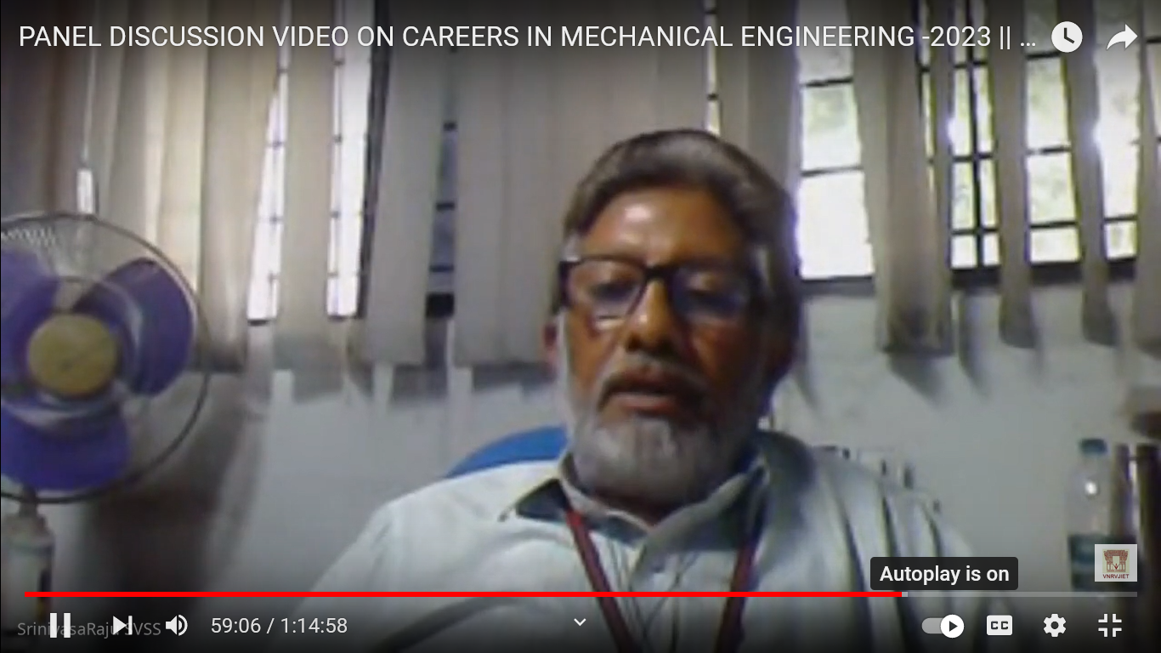
Participation of Dr.S.V.S.S.Srinivasa Raju, Coordinator of ED Cell in the Panel Discussion on Google Meet
- A report on Ecficio-5.0 was prepared, Cash awards of different events in Ecficio-5.0 were distributed among the Prize winners through NEFT by accounts department of VNRVJIET and the advance account settled by ED Cell with the accounts department of VNRVJIET on 18-05-2023.

(ED Cell & MSME VJTBI Coordinators)
Dr.S.V.S.S.Srinivasa Raju, Professor of Mechanical Engineering, Coordinator, ED Cell & Manager, MSME Business Incubator
Dr.M.Venkata Ramana, Professor of Automobile Engineering & Coordinator, ED Cell.

