A Report on Entrepreneurship Development Cell & MSME Vignana Jyothi Technology Business Incubator (MSME VJTBI) Activities for the Month of April, 2023.

I) ED Cell Activities:

- World Intellectual Property Day-2023 celebrations were held at Dr.A.P.J.Abdukl Kalam Auditorium on 26-04-2023 from 03.00 PM to 04.30 PM .Entrepreneurship Development Cell (ED Cell) and IP Cell of VNRVJIET celebratedWorld Intellectual Property Day-2023 (World IP Day-2023) with a theme of “Women and IP: Accelerating Innovation and Creativity” in association with Confederation of Indian Industry (CII), Hyderabadat our Institute by arranging an expert talk with Dr Divya Singh, IP officer, CSIR-CCMB, Hyderabad. Dr.C.D.Naidu, Principal,Dr. B. ChennaKesava Rao, Director for Advancement, Dr.S.V.S.S.Srinivasa Raju, Dr.M.Venkata Ramana, Coordinators of ED Cell VNRVJIET, Dr.K.Ajay, Coordinator ,IP Cell, Dr.N.Sudhakar Yadav, Dr.K.Vijay Chandra, K.Bheema Lingappa, Md.Aziz Athani, R Ravi Kumar, S.Sandeeepraj, Department ED Cell Coordinators of AE,ME,IT,EIE,CSE,ECE and EEE along with interested Faculty have participated in the programme, in which 128 Students and 13 Faculty have enthusiastically participated.
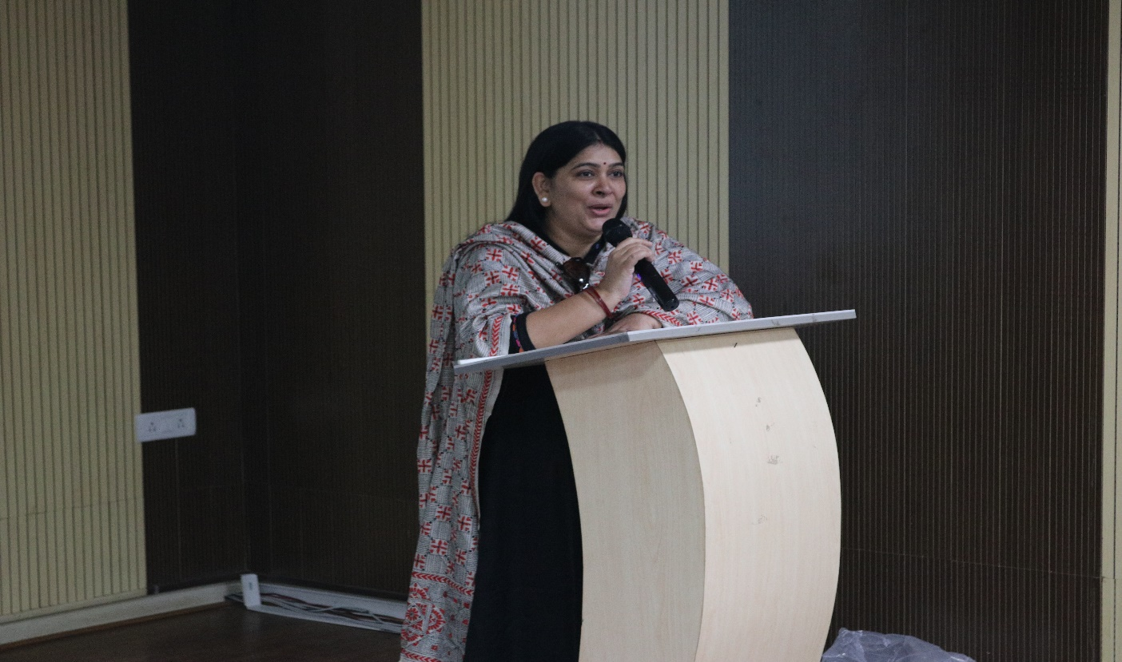
An expert talk on World IP Day-2023 with the theme of “Women and IP: Accelerating Innovation and Creativity”Dr Divya Singh, IP officer, CSIR-CCMB, Hyderabad at Dr.A.P.J.Abdukl Kalam Auditorium, VNRVJIET by ED Cell, IP Cell and CII,Hyderabad on 26-04-2022.
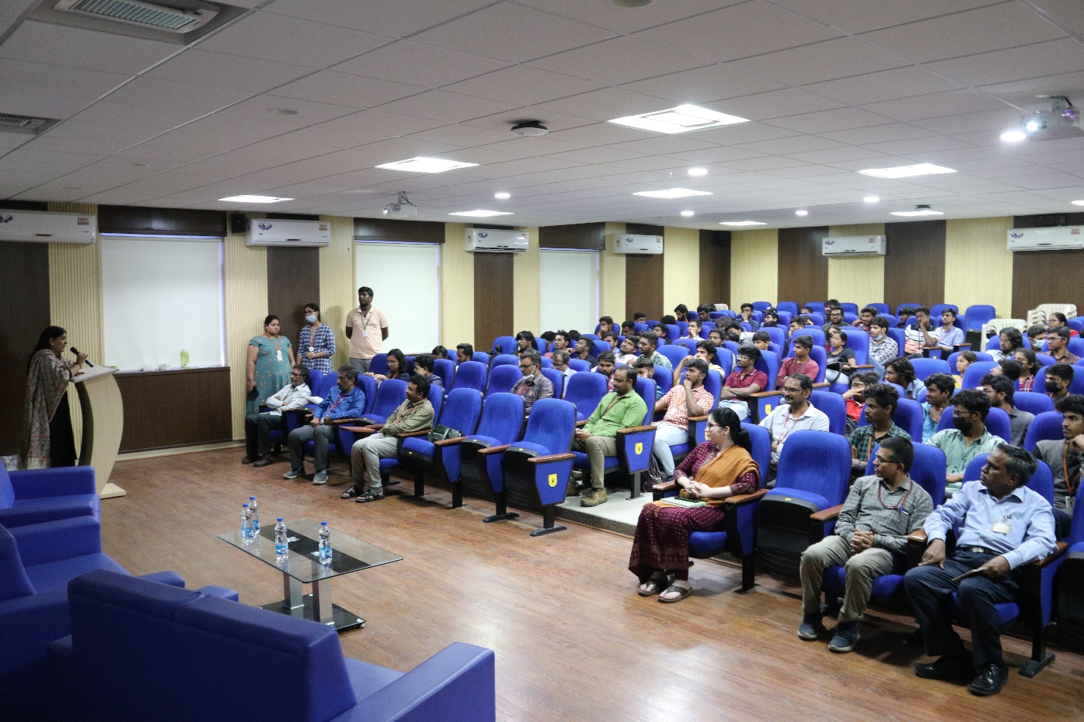

Participants of World Intellectual Property Day-2023Celebrations held at Dr.A.P.J.Abdukl Kalam Auditorium organized by ED Cell, IP Cell of VNRVJIETand CII,Hyderabad.

- Ecficio 5.0 was organized during 24-28 April 2023 at VNRVJIET. 288 students were participated in this event (AE- 9; CE – 2; CSE and CSE allied: 147; ECE – 19; EEE – 19; EIE – 39; M.Tech. – HE – 01; IT – 45; ME -07) students have took part in this event. National Level Competition, Expert Talks, Panel discussion, Workshops, Fun events were organized.
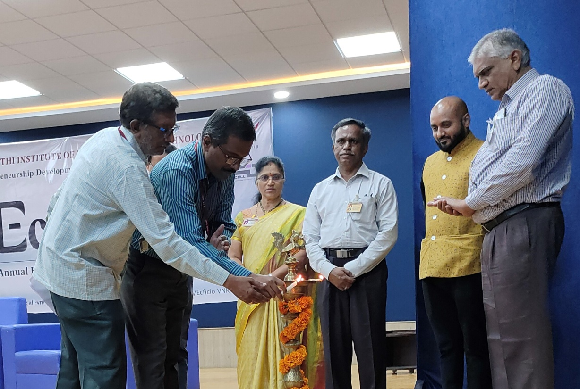

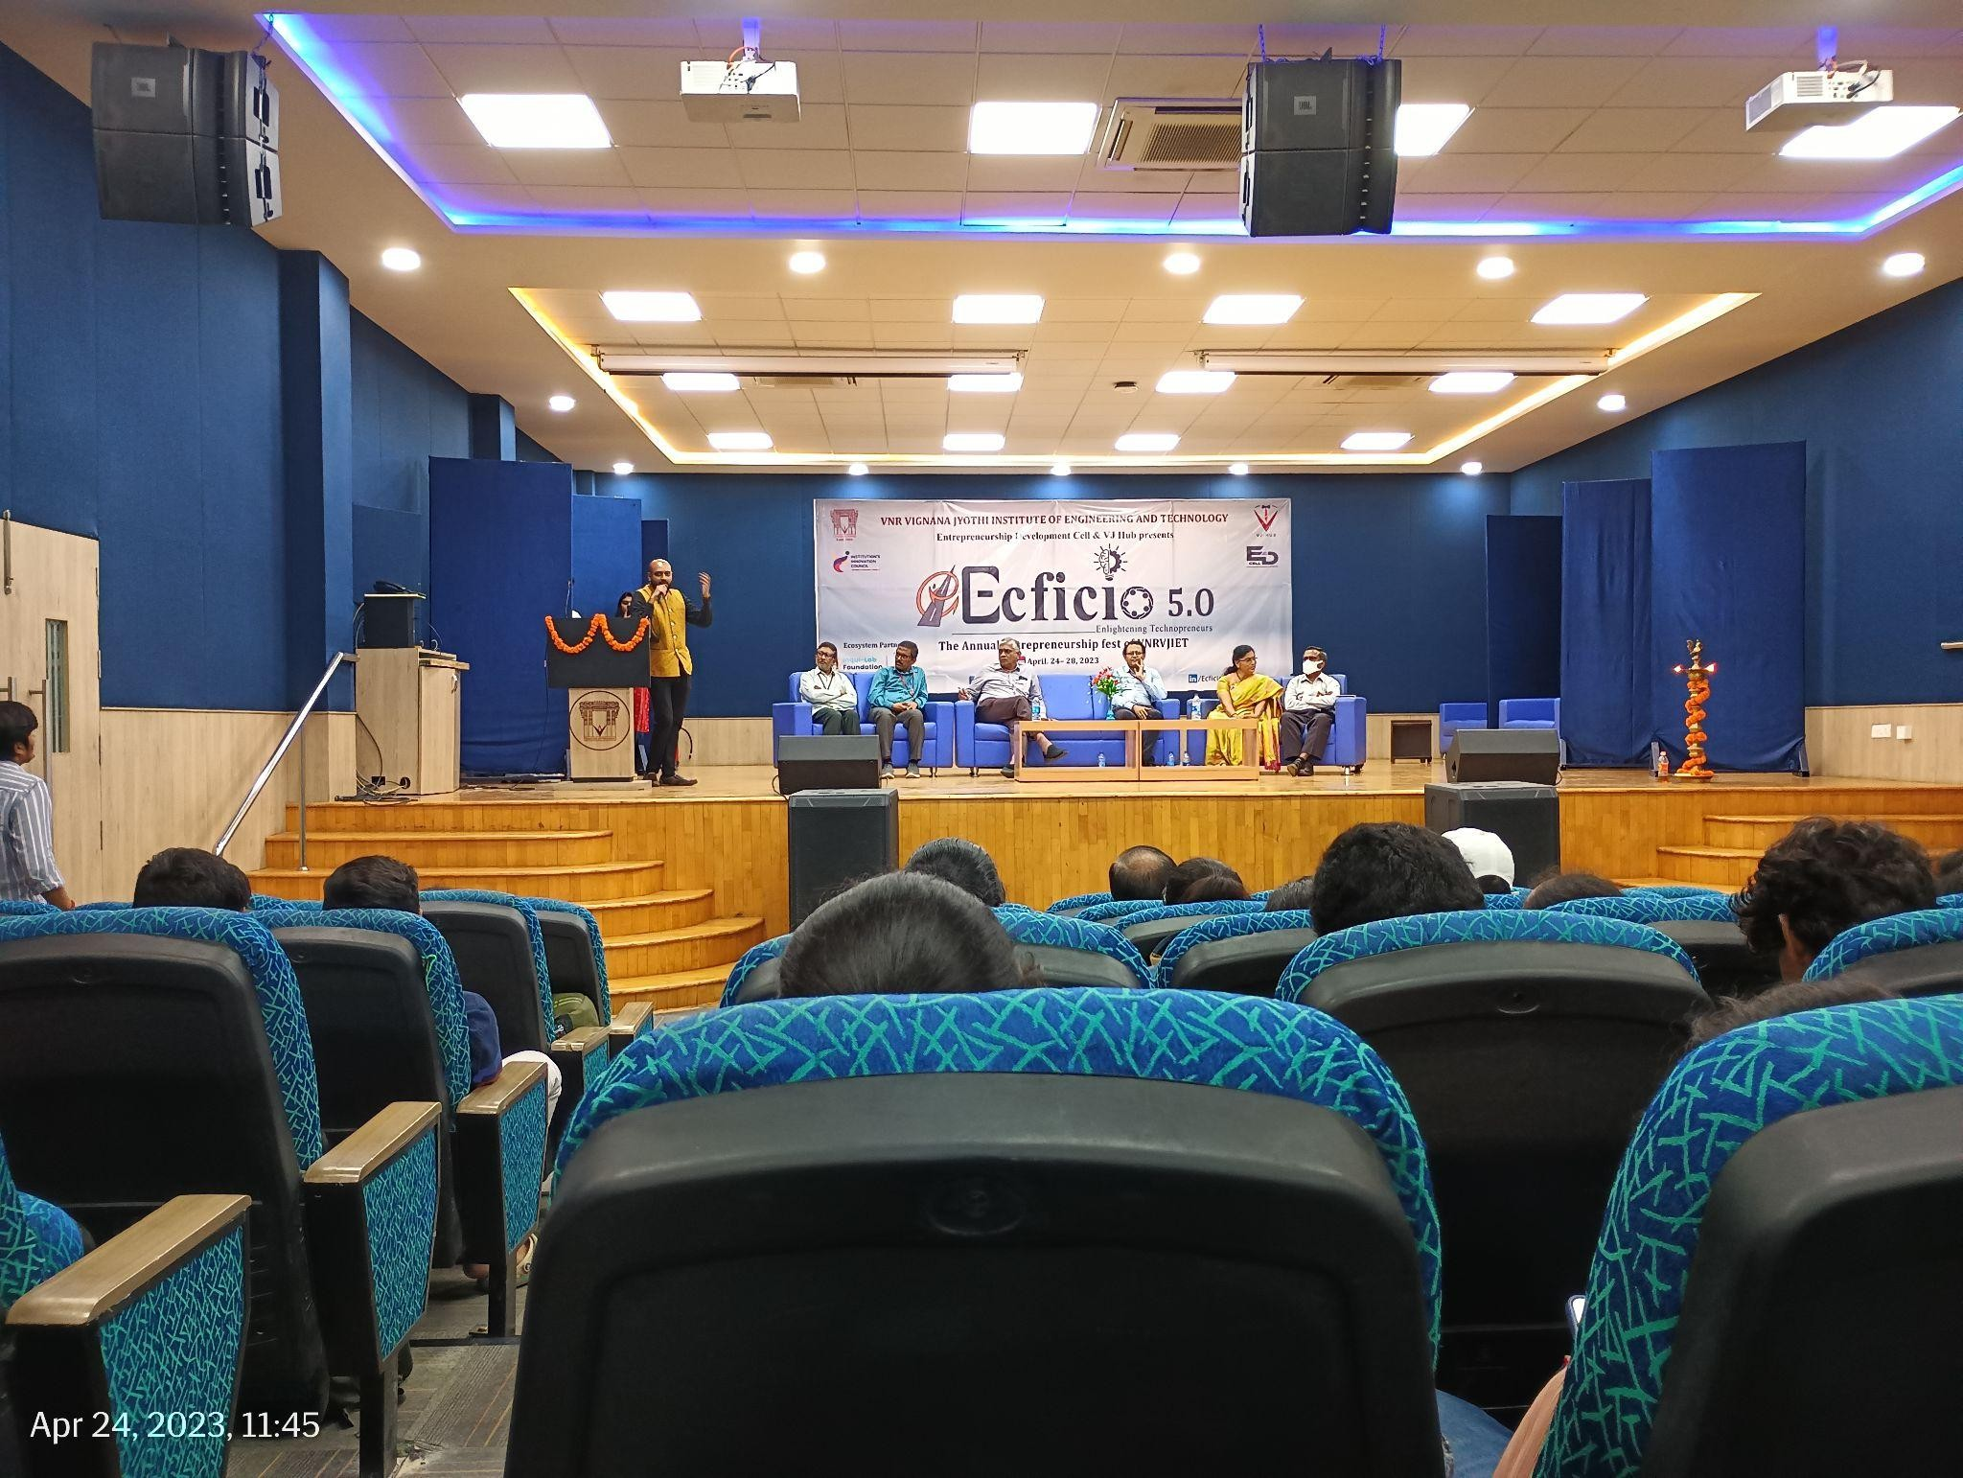

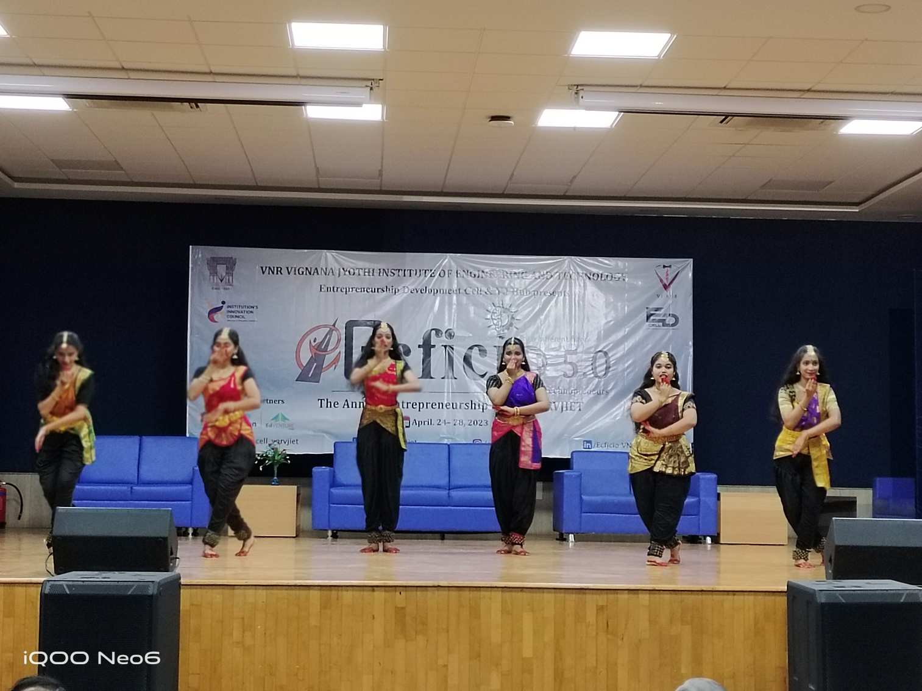
Inauguration of Ecficio – 5.0
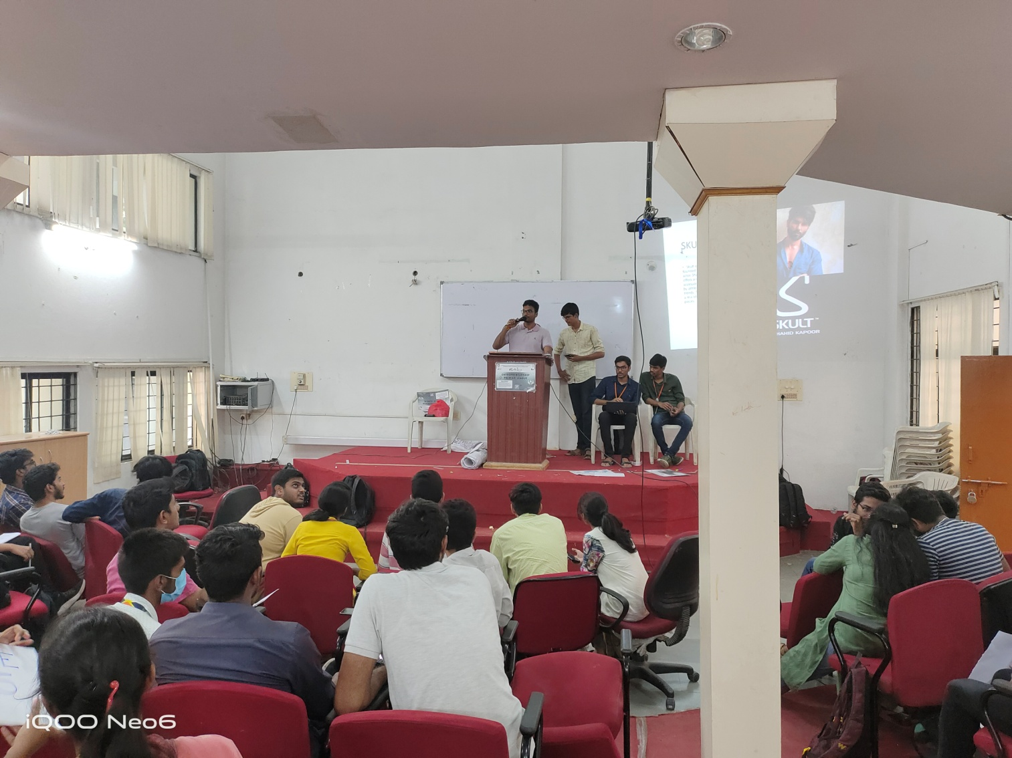

Participation of students in EPL event of Ecficio – 5.0

(ED Cell & MSME VJTBI Coordinators)
Dr.S.V.S.S.Srinivasa Raju, Professor of Mechanical Engineering, Coordinator, ED Cell & Manager, MSME Business Incubator
Dr.M.Venkata Ramana, Professor of Automobile Engineering & Coordinator, ED Cell.

