A Report on Entrepreneurship Development Cell & MSME Vignana Jyothi Technology Business Incubator (MSME VJTBI) Activities for the Month of February, 2023.

I) ED Cell Activities:

- 41 - III B.Tech students (ECE – 20, IT – 15, CyS – 1, AE – 4 and CSE -1) and 3 Faculty members of IT, EIE and DS and CyS branches have visited T-Hub, Hyderabad on 10.02.2023.
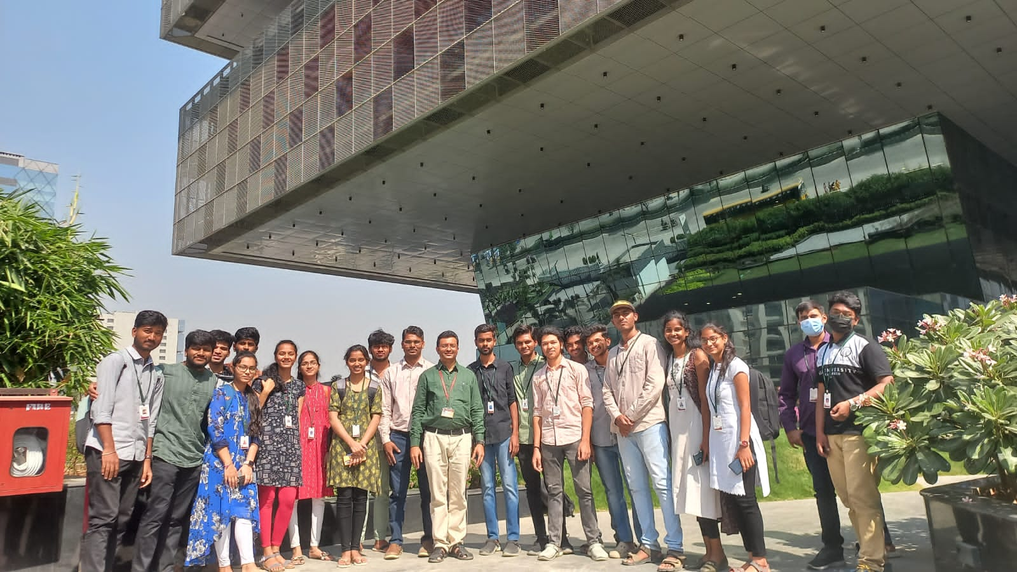

II) MSME & VJTBI Activities:

- Dr.S.V.S.S.Srinivasa Raju, Manager, MSME Business Incubator and Dr. M.Venkata Ramana, Coordinator of ED Cell have attended Training Session on Idea Development & PFMS under MSME Idea Hackathon 2022 on14.02.2023 at Malla Reddy Engineering College, Hyderabad.

(ED Cell & MSME VJTBI Coordinators)
Dr.S.V.S.S.Srinivasa Raju, Professor of Mechanical Engineering, Coordinator, ED Cell & Manager, MSME Business Incubator
Dr.M.Venkata Ramana, Professor of Automobile Engineering & Coordinator, ED Cell.

