A Report on Entrepreneurship Development Cell & MSME Vignana Jyothi Technology Business Incubator (MSME VJTBI) Activities for the Month of October 2023.

I) ED Cell Activities:

- ED Cell students’ body has organized Startup Race event on 13.10.2023 between 02.30 PM and 05.00 PM. 210 students from all the branches have registered for the event. 109 students participated in the event. The following teams were awarded the prize money in order of merit.
1st - RISE (Shumailah Usmani & Team) – Rs. 3,000/-
2nd - Hustle and Hurdels (Maheshwar P & Team) - Rs. 2,000/-
3rd - Akatsuki (Yaganti Mithil & Team) - Rs. 1,000/-
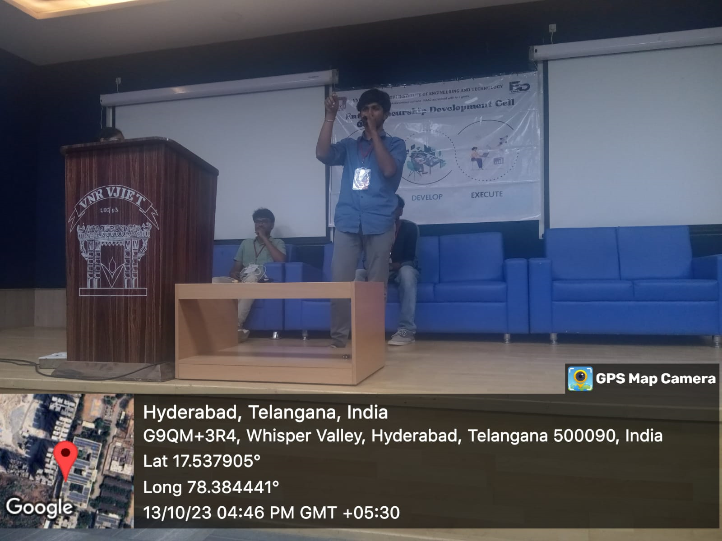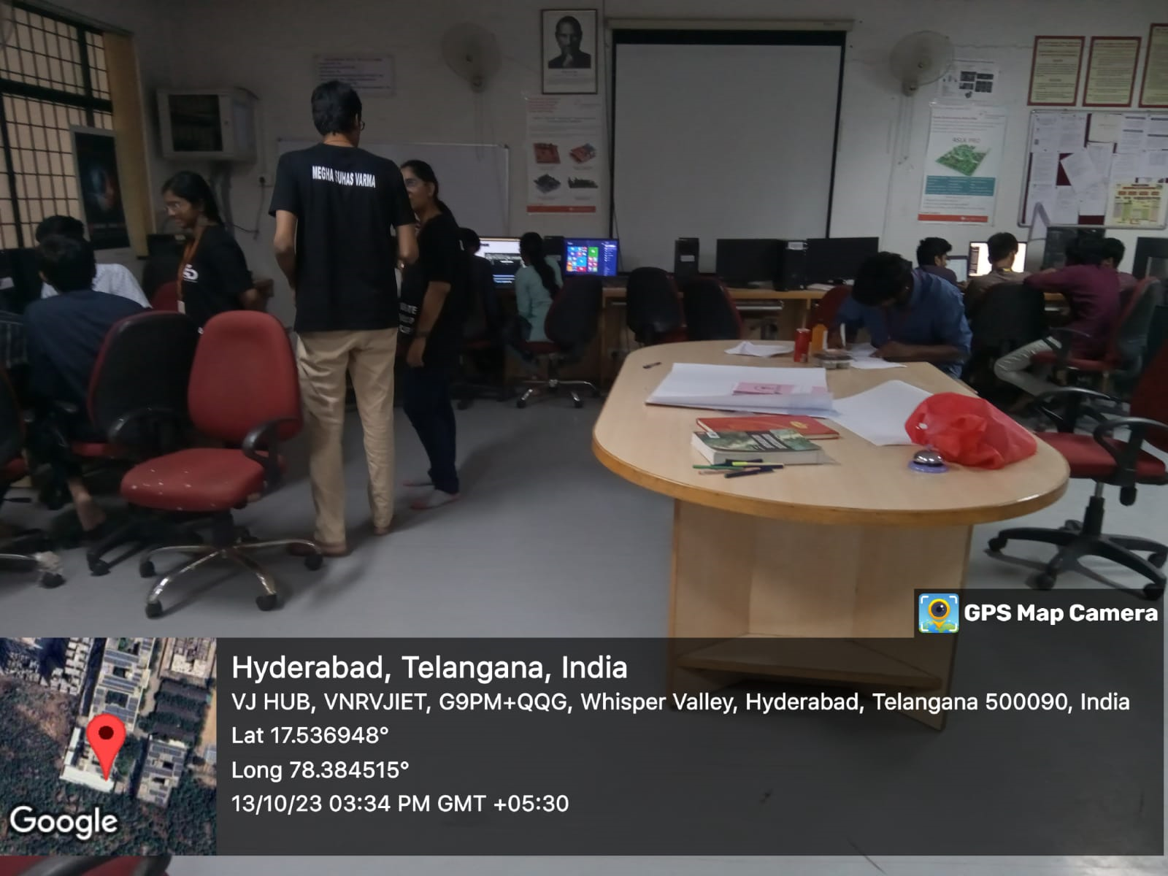

II) MSME & VJTBI Activities:
- Dr. M.Venkata Ramana, Coordinator of ED Cell and Mr. D. Ramesh Reddy, Assistant Professor, ECE have attend the video conference (VC) meeting on review and progress of the MSME Hackathon 2022 projects and address the issues comprehensively on 11.10.2023 at 11.30 Hrs. Senior officers from the Ministry of MSME organized the VC meeting.
- Dr. M. Venkata Ramana, Coordinator of ED Cell and Mr. D. Ramesh Reddy, Assistant Professor, ECE have submitted the revised GFR 12-A (Utilization Certificate) on 19.10.2023 for the I installment in MSME portal to release the II installment of the grant.

Dr. M. Venkata Ramana,
Professor of Automobile Engineering &
Coordinator, ED Cell.

