

**VNR VIGNANA JYOTHI INSTITUTE OF ENGINEERING AND TECHNOLOGY**

An Autonomous Institute, NAAC Accredited with ‘A++’ Grade and NBA Accredited

Approved by AICTE, New Delhi, Affiliated to JNTU Hyderabad

Recognized as “College with Potential for Excellence” by UGC

**DEPARTMENT OF AUTOMOBILE ENGINEERING**

**INDUSTRIAL VISITS**

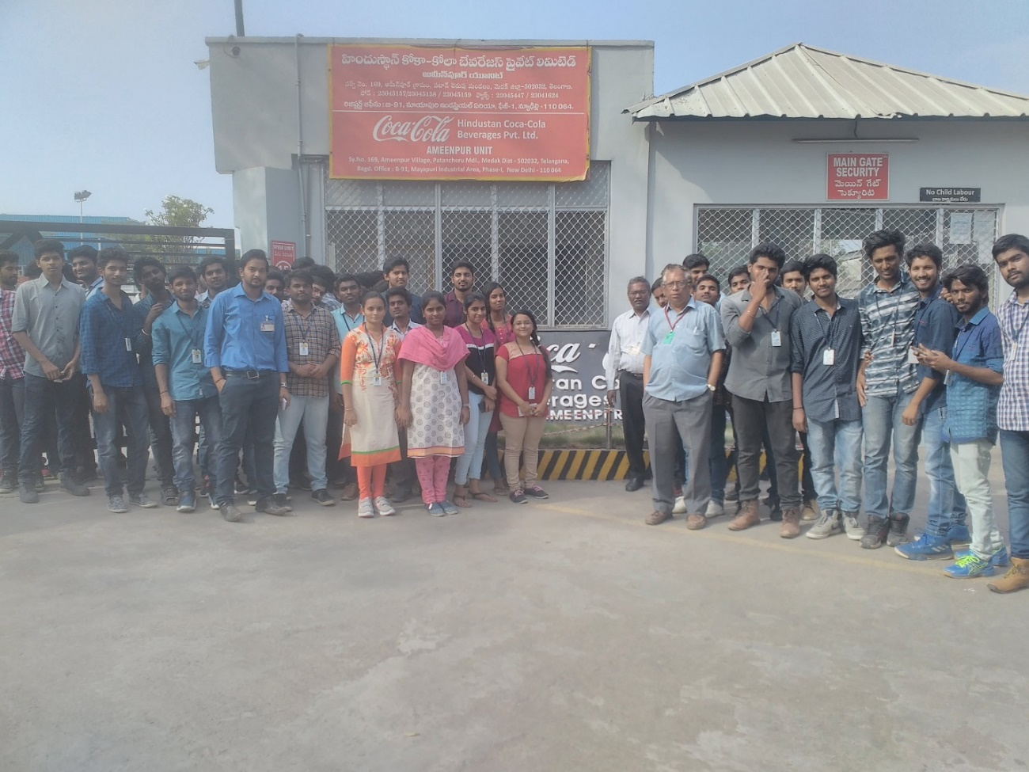

**II Year Automobile engineering students along with faculty during the industrial unit visit to Coca Cola on 22.03.2018**

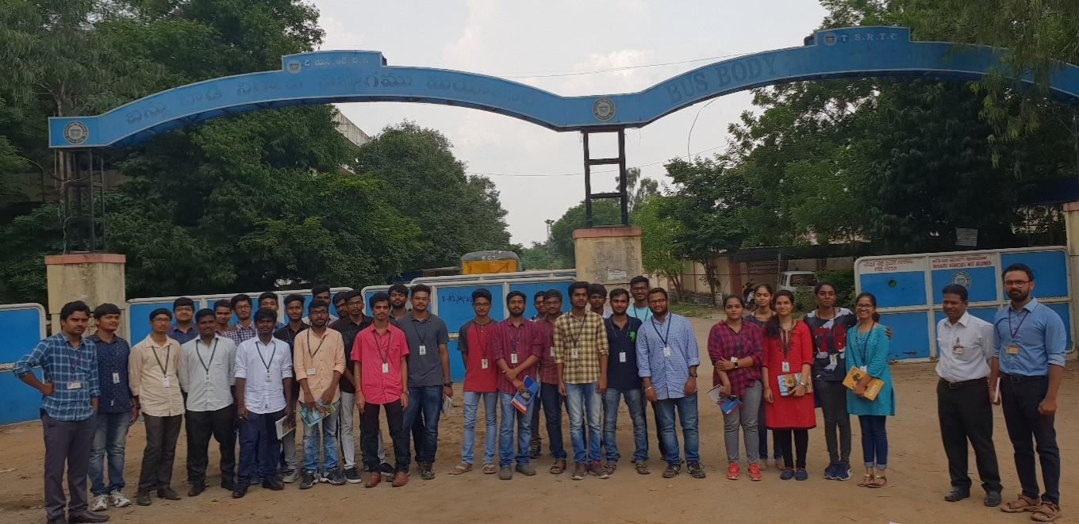

**Automobile engineering Students along with faculty visited TSRTC-Bus Body Building Unit, Miyapur on 25-09-2018 & 26-09-2018**

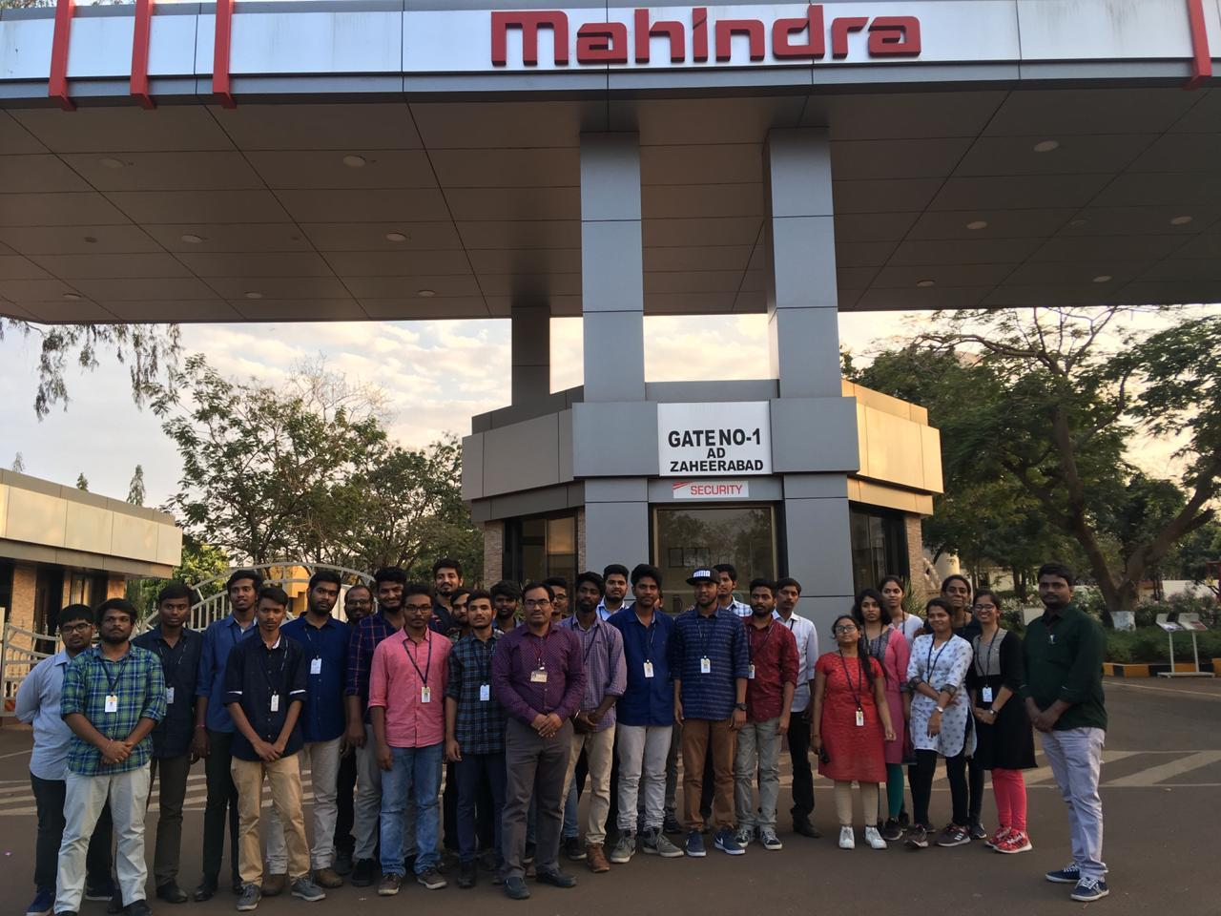

**Students visited Mahindra & Mahindra, Zaheerabad on 21-02-2019**

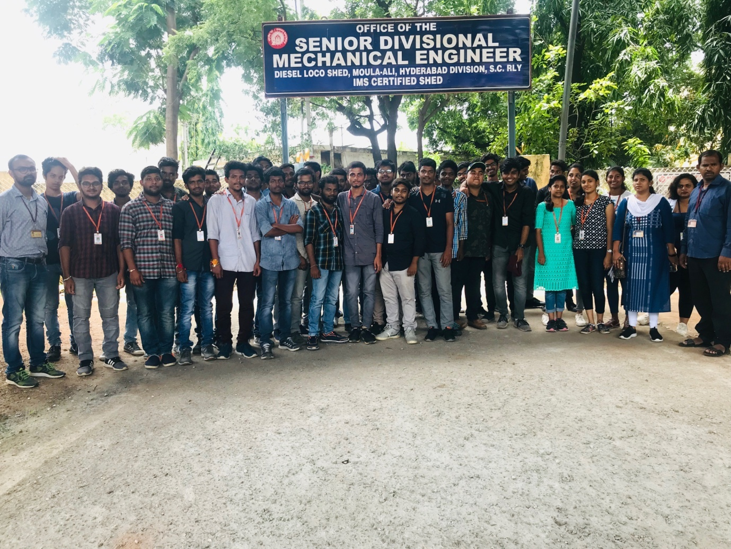

**Automobile engineering students along with faculty during the industrial unit visit to DIESEL LOCO SHED – MOULALI on 14.08.2019**

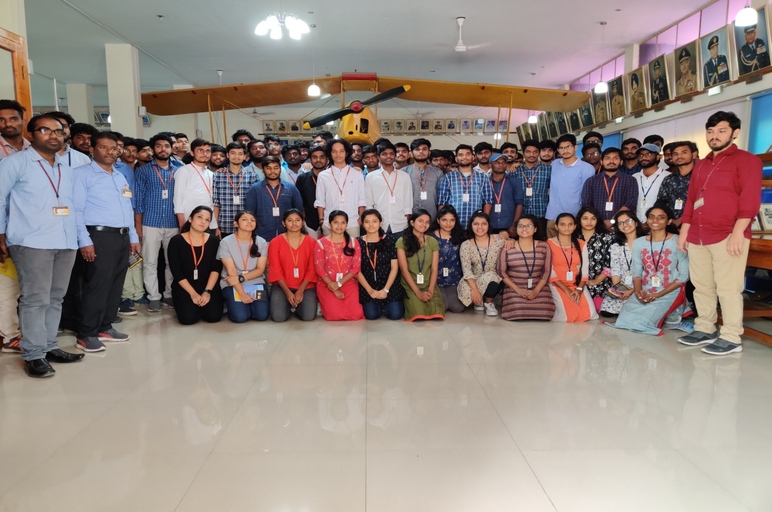

**Automobile engineering students along with faculty during the industrial unit visit to AIR FORCE ACADEMY, DUNDIGAL on 21.01.2020**

**Industrial field visits**

|  |  |  |  |  |  |  |  |
| --- | --- | --- | --- | --- | --- | --- | --- |
| **Company Name** | **Company Sector** | **Incorporation Status** | **Discipline** | **Level** | **Date** | | **No Of** |
| **From** | **To** | **Students** |
| APSRTC Zonal Workshop, Uppal, Hyderabad | Servicing | Public Sector | Automobile engineering | B.Tech | 15- 04-2015 | 16-04-2015 | 60 |
| APSRTC Zonal Workshop, Uppal, Hyderabad | Servicing | Public Sector | Automobile engineering | B.Tech | 07-09-2016 | 09-09-2016 | 45 |
| Thermal systems, Bollaram, Hyderabad | Manufacturing | private | Automobile engineering | B.Tech | 10-09-2016 | 10-09-2016 | 20 |
| Fibre packs, Pragathi Nagar, Hyderabad | Production | Private | Automobile engineering | B.Tech | 12-07-2017 | 12-07-2017 | 52 |
| Sri Sai Enterprises, Bollaram, Hyderabad | Production | Private | Automobile engineering | B.Tech | 12-07-2017 | 12-07-2017 | 52 |
| Shriji Polymers, Kompally, Hyderabad | Production | Private | Automobile engineering | B.Tech | 12-07-2017 | 12-07-2017 | 52 |
| Sri Karthikeya Jute products, Hyderabad | Production | Private | Automobile engineering | B.Tech | 12-07-2017 | 12-07-2017 | 52 |
| HMT machine tools Ltd | Production | Public Sector | Automobile engineering | B.Tech | 27-02-2018 | 27-02-2018 | 50 |
| Hindustan Coca-Cola Beverages Private Limited.-Bollaram | Production | Private | Automobile engineering | B.Tech | 02-04-2018 | 02-04-2018 | 54 |
| TSRTC-Bus Body Building Unit, Miyapur, Hyderabad | Servicing | Public Sector | Automobile engineering | B.Tech | 25-09-2018 | 26-09-2018 | 61 |
| Hindustan Coca-Cola Beverages Private Limited.-Bollaram | Production | Private | Automobile engineering | B.Tech | 25-01-2019 | 25-01-2019 | 25 |
| Mahindra & Mahindra, Zaheerabad, Sanga Reddy | Production | Private | Automobile engineering | B.Tech | 21-02-2019 | 21-02-2019 | 32 |
| Jayem Automotives Pvt. Ltd. (AmTx), Rajabollaram, Medchal | Production | Private | Automobile engineering | B.Tech | 03-04-2019 | 03-04-2019 | 58 |
| Diesel Loco Shed, Moula-Ali | Service | Private | Automobile engineering | B.Tech | 14-08-2019 | 15-08-2019 | 52 |
| Air Force Academy-Dundigal | Service and training | Public Sector | Automobile engineering | B.Tech | 21-01-2020 | 21-01-2020 | 111 |